
FACULTY OF COMPUTER SYSTEM AND SOFTWARE ENGINEERING
BCS 3323 SOFTWARE TESTING & MAINTENANCE

TEST DESIGN SPECIFICATION
FOOD ORDERING SYSTEM (FOS)
UPDATE ORDER STATUS
Independent Verification and Validation

Version: 1.0.0
Date: 21/11/2017

Document Control

Document Name | FOS Test Design Specification
Reference Number | FOS_TDS_1.0.0
Version | 1.0.0
Project Code | TZARIA INC._FOS
Status | In-Use
Date Released | 21/11/2017

Name | Role | Contact Number
Prepared By:  NURSYAZWANI BINTI MD SHAFII | Test Manager  TZARIA INC.
Reviewed By:  NUR SHAHIRAH BINTI MOHAMAD FAIZAL | Quality Assurance Team  TZARIA INC.

Version History
Version | Release Date | Section | Amendments
1.0.0 | 21/11/2016 | All | Original Document

Distribution List
Version | Release Date | Contolled Copy No | Receipient Name | Department | Issue Date | Return Date
1.0.0 | 21/11/2016 | 01 |  | TZARIA INC. QA Dept. | 21/11/2016
1.0.0 | 21/11/2016 | 02 |  | TZARIA INC. Test Team | 21/11/2016
1.0.0 | 21/11/2016 | 03 |  | NKMM | 21/11/2016

Table of Content

Document Control i
Version History ii
Distribution List ii
Table of Content iii
1.0 Introduction 1
1.1 Purpose 1
1.2 Scope 1
1.3 References 1
2.0 Test Design 2
2.1 Features To Be Tested 2
2.2 Approach Refinements 2
2.3 Test Identification 6
2.4 Feature Pass/Fail Criteria 7
2.5 Test Deliverable 7

1.0 Introduction

1.1 Purpose
This test design specification support the following objectives:
- To identify the test items covered
- To further refine the test approach from test plan
- To define the sources of the information used to prepare the plan
- To identify the general cases of test to be executed

1.2 Scope
This test design specification covers Update Order Status features developed in FOS.

1.3 References
The following IEEE standards have been referenced in preparation of this document:
- IEEE 829-2008 Standard for Software and System Test Documentation

The following documents provide the test basis for this test design:
- The FOS Software Requirement Specifications (FOS_SRS_2.0)
- The FOS System Design Specifications (FOS_SDS_2.0)

2.0 Test Design

2.1 Features to Be Tested

The following table contains the features to be tested based on FOS Software Requirement Specification (SRS) for this iteration. Listed together are the function ID and its corresponding function and its risk level.

Feature ID | Description | Risk Level
F003 | Update Order Status | High

2.2 Approach Refinements

Feature ID: F003
Test Technique: Use Case Testing, State Transition Testing

2.2.1 Use Case Testing

Use case ID | UC003
Use case | F003 Update Order Status
Purpose | To allow user to update order status in the database
Actor | Waiter
Trigger | Waiter login to the system
Precondition | FOS is in 'On' state.
Scenario Name | Step | Action
Main Flow | 1 | Waiter login to the system by inserting username and password
Main Flow | 2 | System displays staff home page
Main Flow | 3 | Waiter select the view order page
Main Flow | 4 | System displays view order page
Main Flow | 5 | Waiter select an update button
Main Flow | 6 | System displays an update order status page and request waiter to insert customer's table number and choose order status
Main Flow | 7 | Waiter insert customer's table number and choose 'waiting' order status
Main Flow | 8 | System sends the information to customer's tablet
 | 9 | System displays view order page
 | 10 | Waiter logout from the system
Alternate Flow 1 (Invalid username) | 1.1 | Waiter insert invalid username
Alternate Flow 1 (Invalid username) | 1.2 | Click “Login” button
Alternate Flow 1 (Invalid username) | 1.3 | System displays message “Invalid username. Please re-enter your username”
Alternate Flow 1 (Invalid username) | 1.4 | Waiter re-enter username
Alternate Flow 2 (Invalid password) | 1.5 | Waiter insert invalid password
Alternate Flow 2 (Invalid password) | 1.6 | Click “Login” button
Alternate Flow 2 (Invalid password) | 1.7 | System displays message “Invalid password. Please re-enter your password”
Alternate Flow 2 (Invalid password) | 1.8 | Waiter re-enter password
Alternate Flow 3 (Invalid login 1-2 times) | 1.9 | Waiter insert invalid username and password
Alternate Flow 3 (Invalid login 1-2 times) | 1.10 | Click “Login” button
Alternate Flow 3 (Invalid login 1-2 times) | 1.11 | System displays message “Invalid login. Please re-enter your username and password”
Alternate Flow 3 (Invalid login 1-2 times) | 1.12 | Waiter re-enter username and password
Alternate Flow 4 (Invalid login 3 times) | 1.13 | Waiter insert invalid username and password
Alternate Flow 4 (Invalid login 3 times) | 1.14 | Click “Login” button
Alternate Flow 4 (Invalid login 3 times) | 1.15 | System displays message “You had invalid login with exceed the limit. Please refer to your manager”
Alternate Flow 4 (Invalid login 3 times) | 1.16 | Waiter cannot login to the system until he/her refers to the manager
Alternate Flow 5 (Cancel during login) | 1.17 | Waiter insert valid username and password
Alternate Flow 5 (Cancel during login) | 1.18 | Waiter click “cancel” during the login process is loading
Alternate Flow 5 (Cancel during login) | 1.19 | System displays login page
Alternate Flow 6 (Change order status) | 7.1 | Waiter insert customer's table number and choose “done” order status
Alternate Flow 6 (Change order status) | 7.2 | System sends the information to customer's tablet
Alternate Flow 6 (Change order status) | 7.3 | System displays view order page
Alternate Flow 6 (Change order status) | 7.4 | Waiter logout from the system
Alternate Flow 7 (Cancel during change order status) | 7.5 | Waiter insert customer's table number and choose “done” order status
Alternate Flow 7 (Cancel during change order status) | 7.6 | Click “cancel ” during system sends the information to customer's tablet
Alternate Flow 7 (Cancel during change order status) | 7.7 | System displays view order page
Alternate Flow 8 (Not response after change order status in 60 seconds) | 9.1 | Waiter does not make any activities in 60 seconds
 | 9.2 | System will pop-up a message “FOS will be logout in 60 seconds”
 | 9.3 | Click “OK”
 | 9.4 | System displays the current page
Alternate Flow 9 (Not response after change order status in 5 minutes) | 9.5 | Waiter does not make any activities after got warned in 5 minutes
 | 9.6 | System will be automatically logout
 | 9.7 | System displays message “Your session has been expired. Please login to continue”
 | 9.8 | Click “OK”
 | 9.9 | System displays login page
Table 2.2.1a Session Verification Use Case

Test Condition ID | Test Condition | Test Coverage ID | Test Coverage | Test data
TCON-03-001 | Main Flow | TCOV-03-001 | Main Flow | Valid login  Valid activity = update  Valid update status = waiting
TCON-03-002 | Alternate Flow 1 (Invalid username) | TCOV-03-002 | Alternate Flow 1 (Invalid username) | Username = Waiter1
TCON-03-003 | Alternate Flow 2 (Invalid password) | TCOV-03-003 | Alternate Flow 2 (Invalid password) | Password = 12345
TCON-03-004 | Alternate Flow 3 (Invalid login 1-2 times) | TCOV-03-004 | Alternate Flow 3 (Invalid login 1-2 times) | Password = Waiter1  Password = 12345
TCON-03-005 | Alternate Flow 4 (Invalid login 3 times) | TCOV-03-005 | Alternate Flow 4 (Invalid login 3 times) | Password = Waiter1  Password = 12345
TCON-03-006 | Alternate Flow 5 (Cancel during login) | TCOV-03-006 | Alternate Flow 5 (Cancel during login) | Press “Cancel”
TCON-03-007 | Alternate Flow 6 (Change order status) | TCOV-03-007 | Alternate Flow 6 (Change order status) | Valid login  Valid activity = update  Valid update status = done
TCON-03-008 | Alternate Flow 7 (Cancel during change order status) | TCOV-03-008 | Alternate Flow 7 (Cancel during change order status) | Press “Cancel”
TCON-03-009 | Alternate Flow 8 (Not response after change order status in 60 seconds) | TCOV-03-009 | Alternate Flow 8 (Not response after change order status in 60 seconds) | Stay at current page for 60 seconds
TCON-03-010 | Alternate Flow 9 (Not response after change order status in 5 minutes) | TCOV-03-010 | Alternate Flow 8 (Not response after change order status in 60 seconds) | Stay at current page for 5 minutes
Table 2.2.1b Session Verification Use Case Test Condition & Coverage

2.2.2 State transition Testing

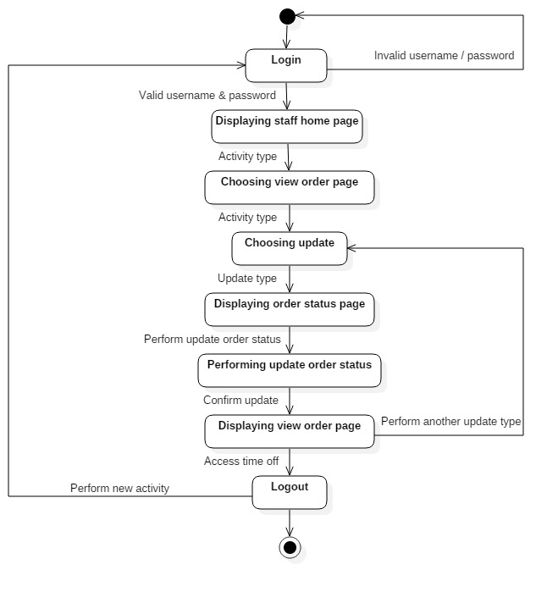
Table 2.2.2 Session Verification State Transition Diagram

2.3 Test Identification
This section should contain information at least as below:

Test Case ID | Description | Test Coverage ID | Test Condition ID
TC-03-001 | Main flow | TCOV-03-001 | TCON-03-001
TC-03-002 | Alternate Flow 1 (Invalid username) | TCOV-03-002 | TCON-03-002
TC-03-003 | Alternate Flow 2 (Invalid password) | TCOV-03-003 | TCON-03-003
TC-03-004 | Alternate Flow 3 (Invalid login 1-2 times) | TCOV-03-004 | TCON-03-004
TC-03-005 | Alternate Flow 4 (Invalid login 3 times) | TCOV-03-005 | TCON-03-005
TC-03-006 | Alternate Flow 5 (Cancel during login) | TCOV-03-006 | TCON-03-006
TC-03-007 | Alternate Flow 6 (Change order status) | TCOV-03-007 | TCON-03-007
TC-03-008 | Alternate Flow 7 (Cancel during change order status) | TCOV-03-008 | TCON-03-008
TC-03-009 | Alternate Flow 8 (Not response after change order status in 60 seconds) | TCOV-03-009 | TCON-03-009
TC-03-010 | Alternate Flow 9 (Not response after change order status in 5 minutes) | TCOV-03-010 | TCON-03-010
Table 2.3 Session Verification Test Identification

2.4 Feature Pass/Fail Criteria

This section should contain information at least as below:

Each feature must satisfy the following criteria in order to pass:
- Pass all its test cases
- No deadlock
- Fulfill its requirement

2.5 Test Deliverable
The following documents will be generated by the system test group and will be delivered after test completion.

Test documentation:
- Test plan
- Test design specifications
- Test case specification
- Test procedure specification
- Test logs
- Test incident report
- Test summary report

